Installing Python
Go to http://www.python.org/getit/releases/2.7/ and download python 2.7 and install it.
After a successful installation you should be able to execute following commands on the command prompt:
____________________

$ python
Python 2.7.2 (r312:79360M, June 11 2011, 01:33:18)
[GCC 4.0.1 (Apple Inc. build 5493)] on darwin
Type "help", "copyright", "credits" or "license" for more info.
>>>
______________

In your command-line prompt, it’ll show you the message on which python has been installed on your machine. When you install Python, you also get IDLE, Python’s integrated development environment.

To open IDLE Click Start>Programs>Python> IDLE( Python GUI)

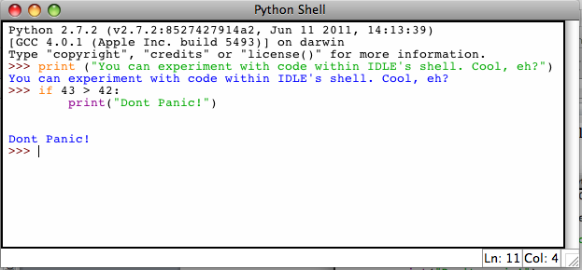

Installing easy_install & pip
Go to http://pypi.python.org/pypi/setuptools#files and download the appropriate installer.

For Windows:
32-bit version of Python
Install setuptools using the provided .exe installer.
64-bit versions of Python
Download ez_setup.py and run it; it will download the appropriate .egg file and install it for you. (Currently, the provided .exe installer does not support 64-bit versions of Python for Windows, due to a distutils installer compatibility issue.
Open Start > Run> Type CMD to open command-prompt. In your command prompt type easy_install pip. This will install pip on your machine.
On Windows, an easy_install.exe launcher will also be installed, so that you can just type easy_install as long as it's on your PATH. If typing easy_install at the command prompt doesn't work, check to make sure your PATH includes the appropriate C:\\Python2X\\Scripts directory. On most current versions of Windows, you can change the PATH by right-clicking "My Computer", choosing "Properties" and selecting the "Advanced" tab, then clicking the "Environment Variables" button. PATH will be in the "System Variables" section, and you will need to exit and restart your command shell (command.com, cmd.exe, bash, or other) for the change to take effect. Be sure to add a ; after the last item on PATH before adding the scripts directory to it.

Installing Python Binding for Selenium
Selenium Python bindings provides a simple API to write functional/acceptance tests using Selenium WebDriver. Through Selenium Python API you can access all functionalities of Selenium WebDriver in an intuitive way. Selenium Python bindings provide a convenient API to access Selenium WebDrivers like Firefox, IE and Chrome.
You can download Python bindings for Selenium from http://pypi.python.org/pypi/selenium or you can also use easy_install or pip to install the binding:
______________
easy_install selenium

or

pip install selenium
____________________

Installing Selenium IDE
Selenium IDE is the Firefox plugin that does record-and-playback of interactions with the browser. Use this to either create simple scripts, assist in exploratory testing.
Open up your Firefox and go to http://seleniumhq.org/download/ then download Selenium IDE.
Click Allow to proceed with the installation
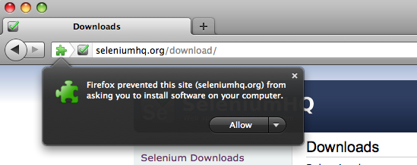

You’ll be prompt with this window and select Install now
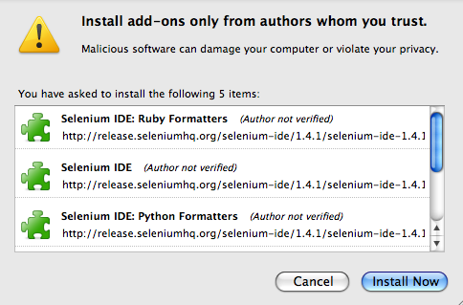

Restart Firefox and you will find Selenium IDE under tools menu and click on it to run the IDE.
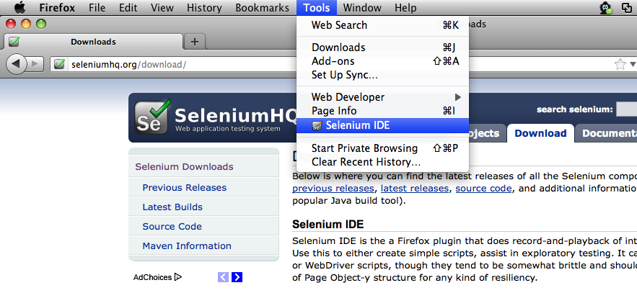

It opens as follows with an empty script-editing window and a menu for loading, or creating new test cases.
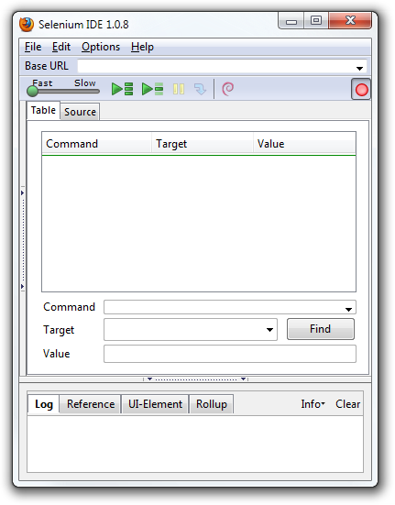

Installing Robot Framework

$ easy_install robotframework

____________________
When using Easy Install on Windows, you need to run robot_postinstall.py script after the installation to configure the runner scripts (pybot, jybot, rebot). The installation output should define where the post-install script is located, and you can execute it by double clicking it or running it from the command line like python <PythonInstallationDir>\Scripts\robot_postinstall.py.

$ pybot --version
Robot Framework 2.5.6 (Python 2.5.4 on linux2
________________

To further verify that Robot Framework is successfully installed. Create a file called:
SimpleTest.txt
Its contents should be the follow:

*** Settings ***
Library Selenium Library

*** Testcases ***
Login Should Succeed When the Correct Username and Password are Entered
Start Selenium Server
Open Browser http://zdiles.chaosnet.org/ chrome
Maximize Browser Window
Input Text uname AUser
Input Text pwd TestPass
Click Button login
Page Should Contain Welcome
Close Browser
Stop Selenium Server

Then execute:

$ Pybot SimpleTest.txt

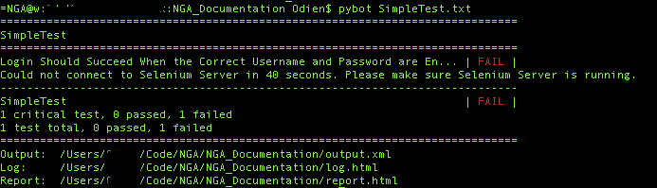

After you execute your test, you should have 3 files:
- Output.xml
- Log.html
- Report.html
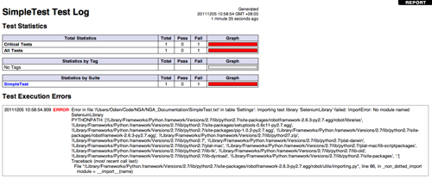
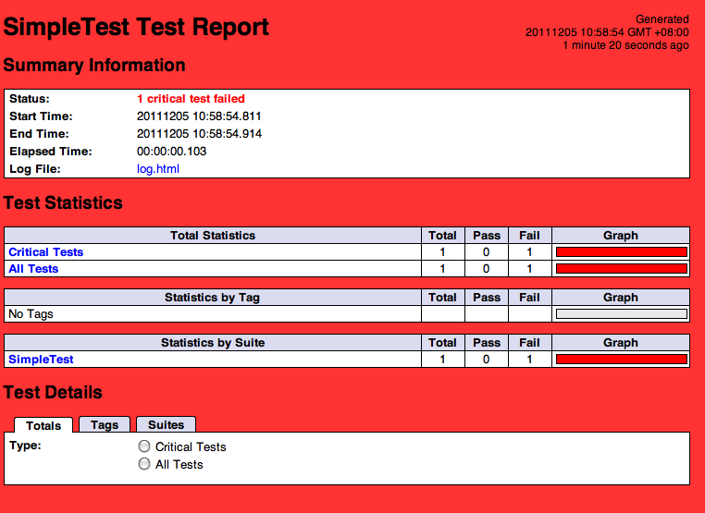

Working on the EWSLibrary:

The EWSLibrary is a robot framework library that exposes NGA’s dummy_classes testing framework to Robot Framework. The code is stored in a shared code repository called bitbucket that uses a distributed version control software called Git. The following instructions explain how to setup a local machine to access and develop against the EWSLibrary for Robot Framework.

Installing Git
Download and Install version 1.7.5.8 of Git from http://code.google.com/p/msysgit/downloads/list

For more information on git please see the following link:
http://progit.org/book/

Go to Git installation directory and select Git Bash shortcut file e.g. C:\Program Files\Git\Git Bash.
Create any directory (e.g. Desktop\ewsframework) and follow the next step. Make sure the folder name does not have any space (“”).
Run the command below in the Git Bash window.

Get code from GIT Repository:

git clone https://j1z0@bitbucket.org/j1z0/ews_automationframework.git

in the directory you just created lets modify the .git properties directory to exclude some files we don’t want to check into source control.

Note: You need to have bitbucket account.

Make sure .git/info/exclude file looks like this:
# git ls-files --others --exclude-from=.git/info/exclude
# Lines that start with '#' are comments.
# For a project mostly in C, the following would be a good set of
# exclude patterns (uncomment them if you want to use them):
# *.[oa]
# *~
*.swp
*.pyc
log.html
output.xml
report.html

A Few python tools we use for development of the EWSLibrary

install coverage.py to measure code coverage of tests…

pip install coverage

Please see the style guide for information on hacking the EWSLibrary

